**Git Assignment**

1-Create a directory ‘project_dir’ & cd to ‘project_dir’



2-Initialize git version database. (git init)



3-Create a new file index.htm



4-Check the git status. You should find index.html as untracked file.



5-Stage the index.html file



6-Commit index.html



7-Make few changes in index.html & create a new file info.txt file



8-Check git status. You should find index.html & info.txt as untracked files.



9-Configure GIT to ignore all txt files.



10-Again check the git status. You should find only index.html as untracked file



11-State & commit index.html



12-. Log all your comments so far



13-Make some changes in index.html.



14-Revert the change made in the previous step using git command.



15-Again change index.html.



16-Stage index.html





17-Revert back the last stage.



18-Rename ‘add’ command to ‘my-add’.



19-Using my-add command Stage index.html again & commit the changes



20-Revert the last commit.



**GIT BRANCHING**

**SECTION-1 (HTML assignments)**

21-First take a backup of your assignments & projects. This is required because due to incorrect GIT operation you may lose your files.

22-Create an empty directory ‘Assignments’ & cd to ‘Assignments’



23-Create a file README.txt inside ‘Assignments’ & write few lines about the contents of ‘Assignments’ folder



24-Commit README.txt file.



25-Now create a new branch ‘html-assignments’



26-Switch to ‘html-assignments’ branch



27-Copy all HTML assignments inside ‘Assignments’ folder



28-Commit HTML assignments into ‘html-assignments’ branch



29-Make minor changes into few files belonging to ‘html-assignments’ branch



30-Commit those changed files.



31-Switch to master branch.



32-Make minor changes into README.txt file & commit those changes into master.



33-Again switch to ‘html-assignments’ branch.



34-Make minor changes into few files belonging to ‘html-assignments’ branch

35-Commit those changes



36-Switch to master.



37-Merge ‘html-assignments’ branch into master. Confirm all html assignments are shown in master.



38-Finally delete the ‘html-assignments’ branch

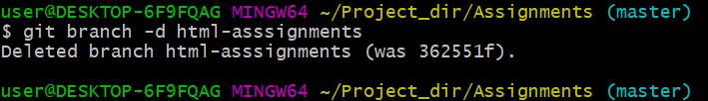

**SECTION-2 - (CSS assignments) Steps to follow:**

1-Create a new branch ‘css-assignments’

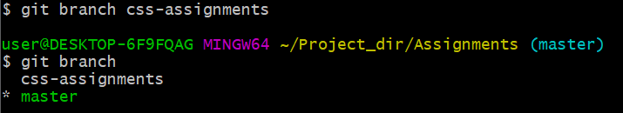

2-Switch to ‘css-assignments’ branch.



3-Copy all CSS assignments inside ‘Assignments’ folder.



4. Commit CSS assignments into ‘css-assignments’ branch.

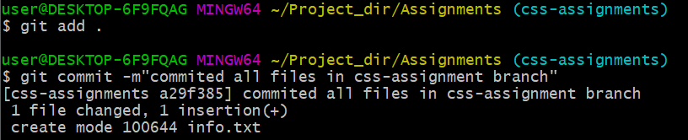

5. Make minor changes into README.txt file on line 1 belonging to ‘css-assignments’ branch.

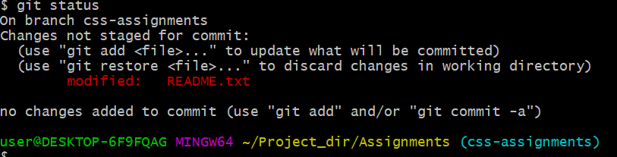

6. Commit those changed files.

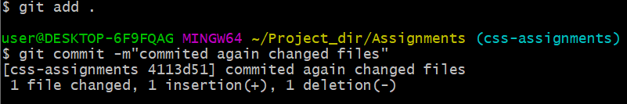

7. Switch to master branch.

8. Make minor changes into README.txt file on line 3 & commit those changes into master.

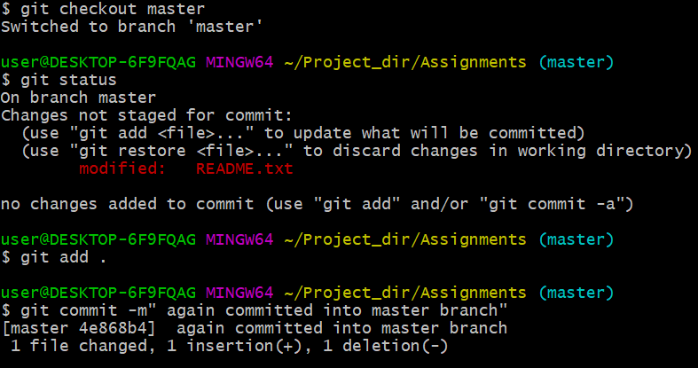

9. Again switch to ‘css-assignments’ branch.

10. Make minor changes into few files belonging to ‘css-assignments’ branch.

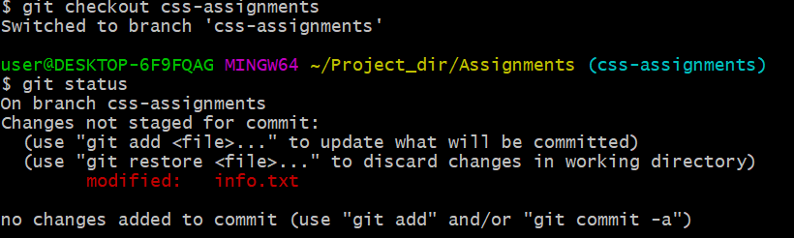

11. Commit those changes.

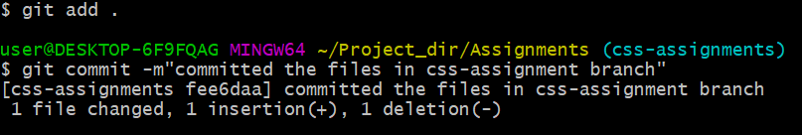

12. Switch to master.

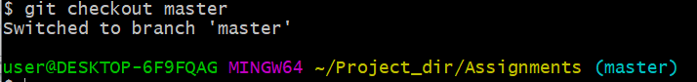

13. Merge ‘css-assignments’ branch into master. Confirm all css assignments are shown in master.

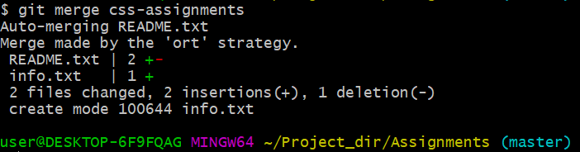

14. Finally delete the ‘css-assignments’ branch.

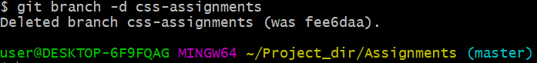

**SECTION-3 - (JavaScript assignments) Steps to follow:**

1. Create a new branch ‘js-assignments’.

2. Switch to ‘js-assignments’ branch.

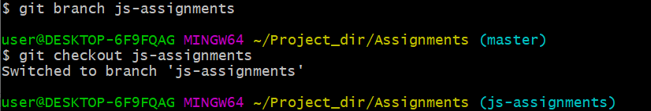

3. Copy all JavaScript assignments inside ‘Assignments’ folder.

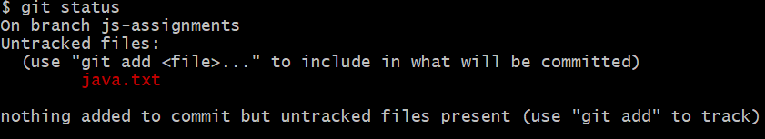

4. Commit JavaScript assignments into ‘js-assignments’ branch.

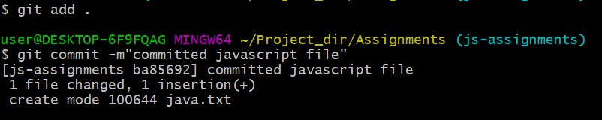

5. Make minor changes into README.txt file on line 1 belonging to ‘js-assignments’ branch.

6. Commit those changed files.

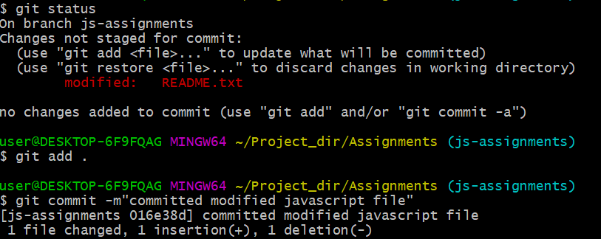

7. Switch to master branch.

8. Make minor changes into README.txt file on line 1 & commit those changes into master.

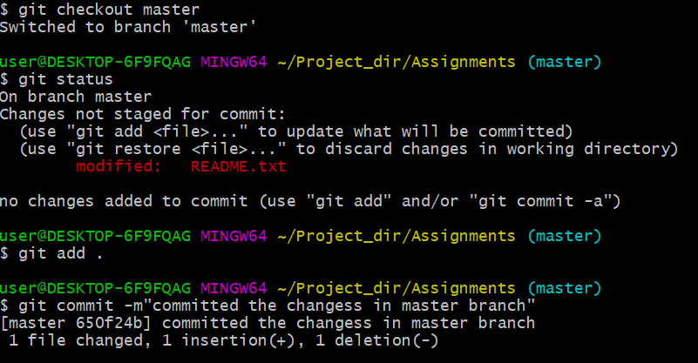

9. Again switch to ‘js-assignments’ branch.

10. Make minor changes into few files belonging to ‘js-assignments’ branch.

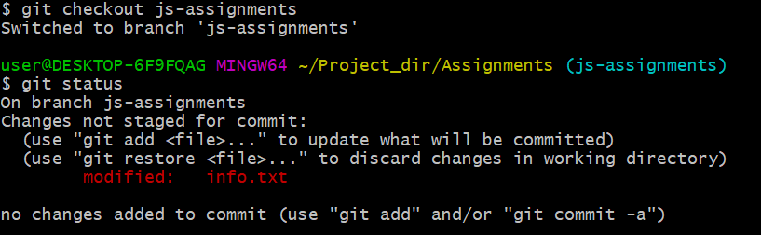

11. Commit those changes.

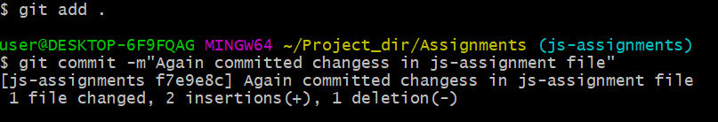

12. Switch to master.

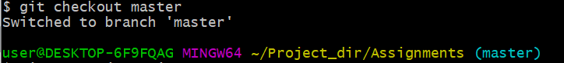

13. Merge ‘js-assignments’ branch into master. Confirm all JavaScript assignments are shown in master.



14. Finally delete the ‘js-assignments’ branch.

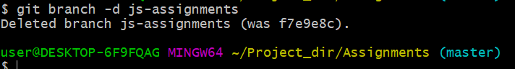

**GIT Remoting**

**SECTION-1 (Pushing assignments to remote repository) - Steps to follow:**

39. Create a github account if you do not have already.

40. Login on into github account.

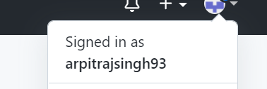

41. Create new public repository ‘freshersbatch-oct16’.

42. Commit & push any sample file to this repository under ‘Assignments’ directory